Task-01
Why is there a need for DBMS?
A Database Management System (DBMS) is needed because it helps store, organize, retrieve, and manage data efficiently and securely. Without a DBMS, managing large amounts of data would be difficult and error prone.
Task-02
Why not traditional DBMS?
A traditional file system stores data in separate files managed by the operating system. It becomes difficult to manage data as the organization grows.
Task 3:
Explain the concept of data independence in DBMS.
Data Independence is the ability to modify the database schema at one level without affecting the schema at the next higher level.
It allows changes in the database structure without changing application programs.
Task 4:
What are the different types of database models (hierarchical, network, relational, object-oriented)?
Explain with examples
Model | Structure | Example
Hierarchical | Tree | Organization hierarchy
Network | Graph | Student-Course
Relational | Tables | MySQL
Object-Oriented | Objects | ObjectDB

Task 5:
Describe concurrency control in DBMS. Why is it important?
Definition
Concurrency Control is the process of managing simultaneous access to the database by multiple users while maintaining data consistency.
Importance
- Prevents data inconsistency
- Avoids lost updates
- Prevents dirty reads
- Maintains ACID properties
- Improves reliability

Task 6:
What are indexes in DBMS? How do they improve query performance?
Definition
An Index is a data structure that improves the speed of retrieving records from a database table.
It works like the index of a book.
Example
Without Index
Find Student ID = 500

Search
1
2
3
...
500
With Index
Index
500 → Record Location

Task 7:
Explain deadlock in DBMS. What are the strategies for deadlock prevention and detection?
Definition
A Deadlock occurs when two or more transactions wait indefinitely for each other to release resources.
Example
Transaction T1
Locks Table A
Waiting for Table B

Transaction T2
Locks Table B
Waiting for Table A

Result:
Deadlock
Deadlock Prevention
Prevention avoids deadlocks before they occur.
Strategies:
- Acquire all required locks at the beginning.
- Request resources in a fixed order.
- Allow resource preemption where possible.
- Avoid the hold-and-wait condition.

Task 8:
What do you understand by Relational model?
It organizes data into tables (relations) consisting of rows (tuples) and columns (attributes). Relationships between tables are established using Primary Keys and Foreign Keys.

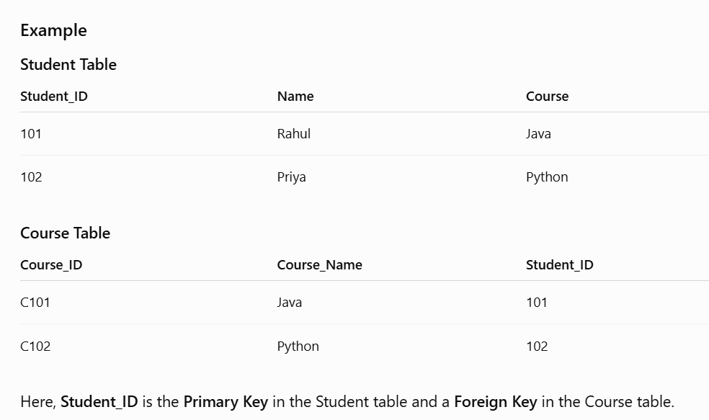
Task 9:
Specify key terms that you encounter in RDBMS. Give brief explanation
Key Term | Brief Explanation
Relation (Table) | A collection of related data stored in rows and columns.
Tuple (Row) | A single record in a table.
Attribute (Column) | A field or property of a table.
Domain | The set of valid values allowed for an attribute.
Primary Key | A column that uniquely identifies each record in a table.
Foreign Key | A column that creates a relationship between two tables by referencing another table's primary key.
Candidate Key | A column or set of columns that can uniquely identify a record.
Alternate Key | A candidate key that is not selected as the primary key.
Composite Key | A key formed by combining two or more columns to uniquely identify a record.
Super Key | Any combination of columns that uniquely identifies a record.
Constraint | Rules applied to maintain data integrity (e.g., NOT NULL, UNIQUE, CHECK, DEFAULT).
Schema | The overall structure or design of a database.
Instance | The actual data stored in the database at a particular point in time.
View | A virtual table created from one or more tables.
Index | A database object that improves the speed of data retrieval.
Normalization | The process of organizing data to reduce redundancy and improve integrity.
SQL (Structured Query Language) | The language used to create, manage, and query relational databases.
Transaction | A group of SQL operations executed as a single unit of work following ACID properties.

Task 10:
What are different types of keys in RDBMS?
Explain using diagrams ..
1. Primary Key (PK)
Definition:
A Primary Key uniquely identifies each record in a table. It cannot contain NULL values and must be unique.
Diagram
STUDENT
+------------+---------+--------+
| Student_ID | Name | Course |
+------------+---------+--------+
| 101 | Rahul | Java |
| 102 | Priya | Python |
| 103 | Arun | SQL |
+------------+---------+--------+

Primary Key = Student_ID

2. Foreign Key (FK)
Definition:
A Foreign Key is a column that references the Primary Key of another table to create a relationship.
Diagram
CUSTOMER
+-------------+--------+
| Customer_ID | Name |
+-------------+--------+
| 101 | Rahul |
| 102 | Priya |
+-------------+--------+
▲
│ Primary Key
│
ORDERS
+----------+-------------+---------+
| Order_ID | Customer_ID | Product |
+----------+-------------+---------+
| 1 | 101 | Laptop |
| 2 | 102 | Mobile |
+----------+-------------+---------+

Customer_ID in ORDERS = Foreign Key

3. Candidate Key
Definition:
A Candidate Key is any column that can uniquely identify a record.
Example
EMPLOYEE

Employee_ID
Email

Both are unique.

Candidate Keys:
✓ Employee_ID
✓ Email

4. Alternate Key
Definition:
A Candidate Key that is not selected as the Primary Key.
Candidate Keys:
Employee_ID
Email

Primary Key = Employee_ID

Alternate Key = Email

5. Composite Key
Definition:
A Composite Key is formed by combining two or more columns.
Diagram
STUDENT_COURSE

+------------+-----------+-------+
| Student_ID | Course_ID | Marks |
+------------+-----------+-------+
| 101 | C101 | 90 |
| 101 | C102 | 85 |
+------------+-----------+-------+

Composite Key = (Student_ID + Course_ID)

6. Super Key
Definition:
A Super Key is any combination of columns that uniquely identifies a record.
Example:
- Employee_ID
- Employee_ID + Name
- Employee_ID + Email
All are Super Keys.

7. Unique Key
Definition:
A Unique Key ensures all values are unique. It generally allows one NULL value (depending on the database system).
Example:
EMPLOYEE

+------------+--------------------+
| Emp_ID(PK) | Email (UNIQUE) |
+------------+--------------------+
|101 |a@gmail.com |
|102 |b@gmail.com |
+------------+--------------------+

Summary Table
Key | Purpose
Primary Key | Uniquely identifies each record
Foreign Key | Creates relationship between tables
Candidate Key | Can uniquely identify records
Alternate Key | Candidate key not selected as PK
Composite Key | Combination of columns as key
Super Key | Any unique column combination
Unique Key | Ensures unique values

Task 11:
As you know diff keys in RDBMS what is the difference between primary key, foreign key, and unique key?

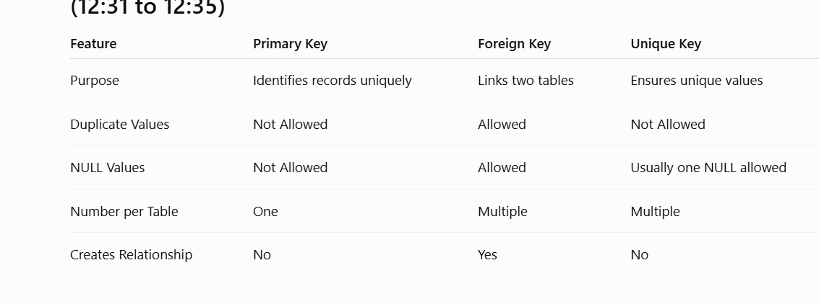

Task 12:
How does transaction management work in DBMS? Give an example of commit and rollback .
Definition
A transaction is a sequence of SQL operations executed as a single unit of work. It follows the ACID properties:
- A – Atomicity: All operations succeed or none do.
- C – Consistency: Database remains valid before and after the transaction.
- I – Isolation: Transactions do not interfere with each other.
- D – Durability: Committed changes are permanently saved.
START TRANSACTION
│
Execute SQL Statements
│
Success?
/ \
Yes No
│ │
COMMIT ROLLBACK
│ │
Save Undo
Changes Changes
Task 13:
What is normalization? Why is it necessary in database design?

Definition
Normalization is the process of organizing data into well-structured tables to reduce data redundancy and improve data integrity.

Why is Normalization Necessary?
- Eliminates duplicate data.
- Improves data consistency.
- Prevents update, insert, and delete anomalies.
- Saves storage space.
- Makes maintenance easier.
- Improves overall database design.

Task 14: What do you understand by 1NF? Explain with an example.
Definition
First Normal Form (1NF) states that:
- Each column should contain atomic (single) values.
- There should be no repeating groups or multiple values in a single column.
- Each row should be unique.

Example (Before 1NF)
Student_ID | Student_Name | Courses
101 | Rahul | Java, SQL
102 | Priya | Python
Here, the Courses column contains multiple values, which violates 1NF.

After Applying 1NF
Student_ID | Student_Name | Course
101 | Rahul | Java
101 | Rahul | SQL
102 | Priya | Python
Now, each cell contains only one value (atomic value).

Task 15: What do you understand about 2NF? Explain with an example.
Definition
Second Normal Form (2NF) states that:
- The table must already be in 1NF.
- Every non-key attribute must depend on the entire primary key, not just part of a composite key.
- It removes partial dependency.

Example (Before 2NF)
Student_ID | Course_ID | Student_Name | Marks
101 | C101 | Rahul | 90
101 | C102 | Rahul | 85
102 | C101 | Priya | 88
Composite Primary Key: (Student_ID, Course_ID)
Here:
- (Student_ID, Course_ID) → Marks ✅
- Student_ID → Student_Name ❌ (Partial Dependency)

After Applying 2NF
Student Table
Student_ID | Student_Name
101 | Rahul
102 | Priya
Enrollment Table
Student_ID | Course_ID | Marks
101 | C101 | 90
101 | C102 | 85
102 | C101 | 88
Now, every non-key attribute depends on the whole key.

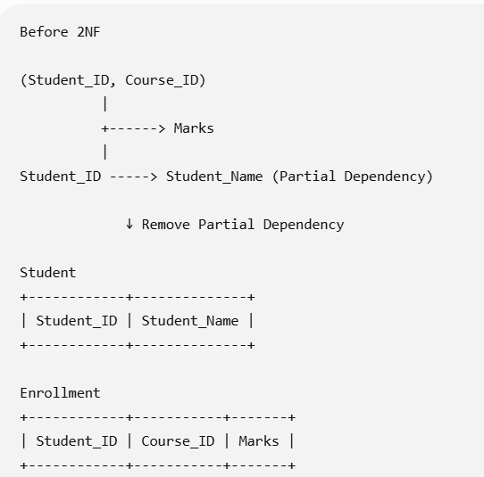
Task-16

What do you understand by 3NF? Explain with an example.
Definition
Third Normal Form (3NF) states that:
- The table must already be in 2NF.
- There should be no transitive dependency.
- A non-key attribute should depend only on the primary key, not on another non-key attribute.

Example (Before 3NF)
Student_ID | Department_ID | Department_Name
101 | D01 | CSE
102 | D02 | ECE
103 | D01 | CSE
Functional Dependencies
Student_ID → Department_ID
Department_ID → Department_Name
Here, Department_Name depends on Department_ID, not directly on Student_ID. This is a transitive dependency.

After Applying 3NF
Student Table
Student_ID | Department_ID
101 | D01
102 | D02
103 | D01
Department Table
Department_ID | Department_Name
D01 | CSE
D02 | ECE
Now, Department_Name depends only on Department_ID.

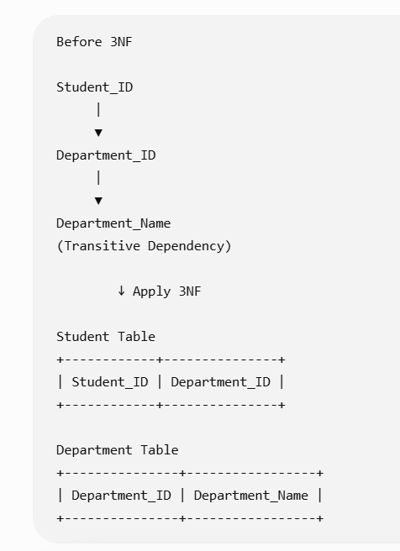

Task-17

What are Joins in SQL?
A Join is an SQL operation used to combine rows from two or more tables based on a related column (usually a Primary Key and Foreign Key).
For example:
Student Table
Student_ID | Name
101 | Alice
102 | Bob
103 | Charlie
Marks Table
Student_ID | Marks
101 | 90
102 | 85
104 | 95
To display student names along with their marks, we use JOIN.
Match onleft.customer_id = right.customer_id
Left table
customer_id | customer
1 | Ava
2 | Bo
4 | Dee
Right table
customer_id | level
1 | Gold
3 | Silver
4 | Bronze
↓
INNER JOIN · Result
customer_id | customer | level
1 | Ava | Gold
4 | Dee | Bronze
Only matching keys 1 and 4 remain
INNER JOINLEFT JOINRIGHT JOINFULL OUTER JOIN
INNER JOINLEFT JOINRIGHT JOINFULL OUTER JOIN

Types of Joins in SQL
1. INNER JOIN
Definition
Returns only the matching records from both tables.
Syntax
SELECT Student.Name, Marks.Marks
FROM Student
INNER JOIN Marks
ON Student.Student_ID = Marks.Student_ID;
Output
Name | Marks
Alice | 90
Bob | 85
Explanation:
- Charlie is not shown because there are no marks.
- Student_ID 104 is not shown because it doesn't exist in the Student table.

2. LEFT JOIN (LEFT OUTER JOIN)
Definition
Returns all records from the left table and the matching records from the right table.
If there is no match, SQL returns NULL for the right table columns.
Syntax
SELECT Student.Name, Marks.Marks
FROM Student
LEFT JOIN Marks
ON Student.Student_ID = Marks.Student_ID;
Output
Name | Marks
Alice | 90
Bob | 85
Charlie | NULL
Explanation:
- Every student is displayed.
- Charlie has no marks, so NULL is shown.

3. RIGHT JOIN (RIGHT OUTER JOIN)
Definition
Returns all records from the right table and matching records from the left table.
If there is no match, NULL is returned for the left table columns.
Syntax
SELECT Student.Name, Marks.Marks
FROM Student
RIGHT JOIN Marks
ON Student.Student_ID = Marks.Student_ID;
Output
Name | Marks
Alice | 90
Bob | 85
NULL | 95
Explanation:
- All marks are displayed.
- Student_ID 104 has no matching student, so Name is NULL.

4. FULL OUTER JOIN
Definition
Returns all matching and non-matching records from both tables.
Syntax
SELECT Student.Name, Marks.Marks
FROM Student
FULL OUTER JOIN Marks
ON Student.Student_ID = Marks.Student_ID;
Output
Name | Marks
Alice | 90
Bob | 85
Charlie | NULL
NULL | 95
Explanation:
- Displays every record from both tables.
- Non-matching rows contain NULL values.
Note: MySQL does not support FULL OUTER JOIN directly. It can be simulated using LEFT JOIN UNION RIGHT JOIN.

5. CROSS JOIN
Definition
Returns the Cartesian product of two tables.
Each row from the first table is combined with every row from the second table.
Syntax
SELECT Student.Name, Course.Course_Name
FROM Student
CROSS JOIN Course;
Suppose:
Course Table
Course_Name
Java
Python
Output
Name | Course_Name
Alice | Java
Alice | Python
Bob | Java
Bob | Python
Charlie | Java
Charlie | Python
Explanation:
If there are 3 students and 2 courses, the result contains 3 × 2 = 6 rows.

6. SELF JOIN
Definition
A Self Join joins a table with itself.
It is useful for finding relationships within the same table, such as employees and their managers.
Employee Table
Emp_ID | Employee | Manager_ID
1 | John | NULL
2 | Alice | 1
3 | Bob | 1
Syntax
SELECT E.Employee AS Employee_Name,
M.Employee AS Manager_Name
FROM Employee E
LEFT JOIN Employee M
ON E.Manager_ID = M.Emp_ID;
Output
Employee_Name | Manager_Name
John | NULL
Alice | John
Bob | John
Explanation:
The Employee table is joined with itself to display each employee along with their manager.

